Sql assignment 4: stored procedure

( query 1 added to blocker )

2. write a SQL query to Create Stored procedure in the Northwind database to retrieve

Employee Sales by Country

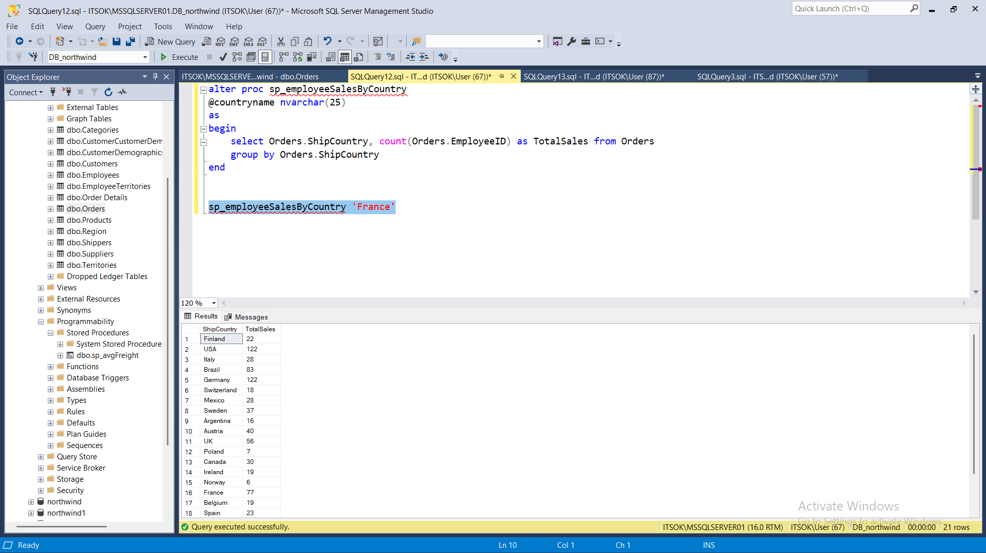

5. write a SQL query to Create Stored procedure in the Northwind database to retrieve

Ten Most Expensive Products

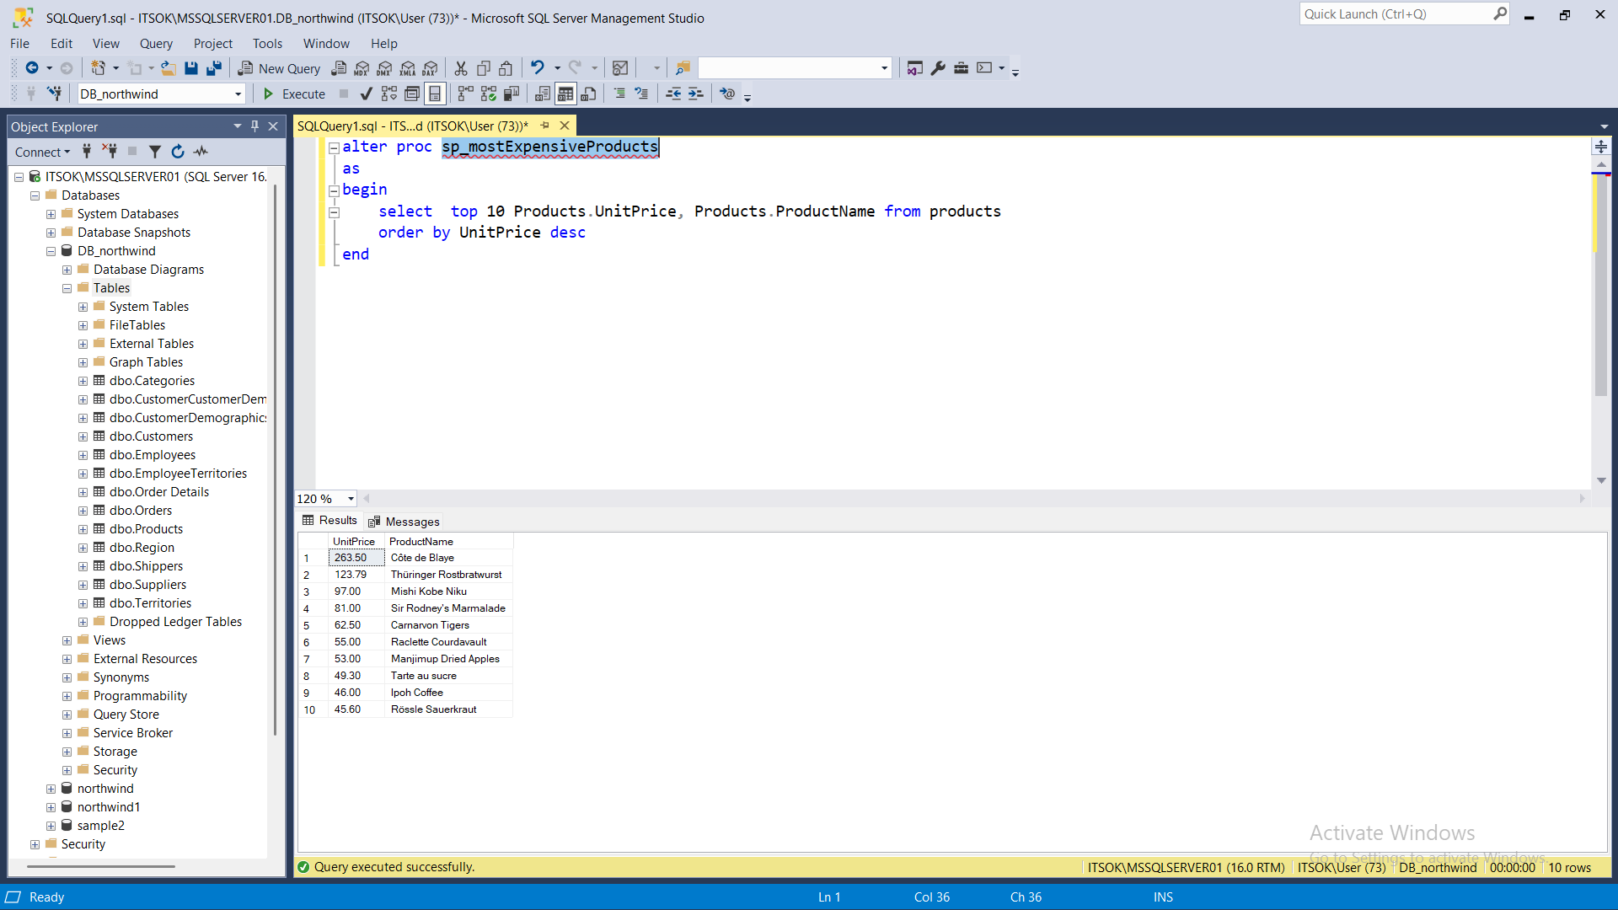

6. write a SQL query to Create Stored procedure in the Northwind database to insert

Customer Order Details

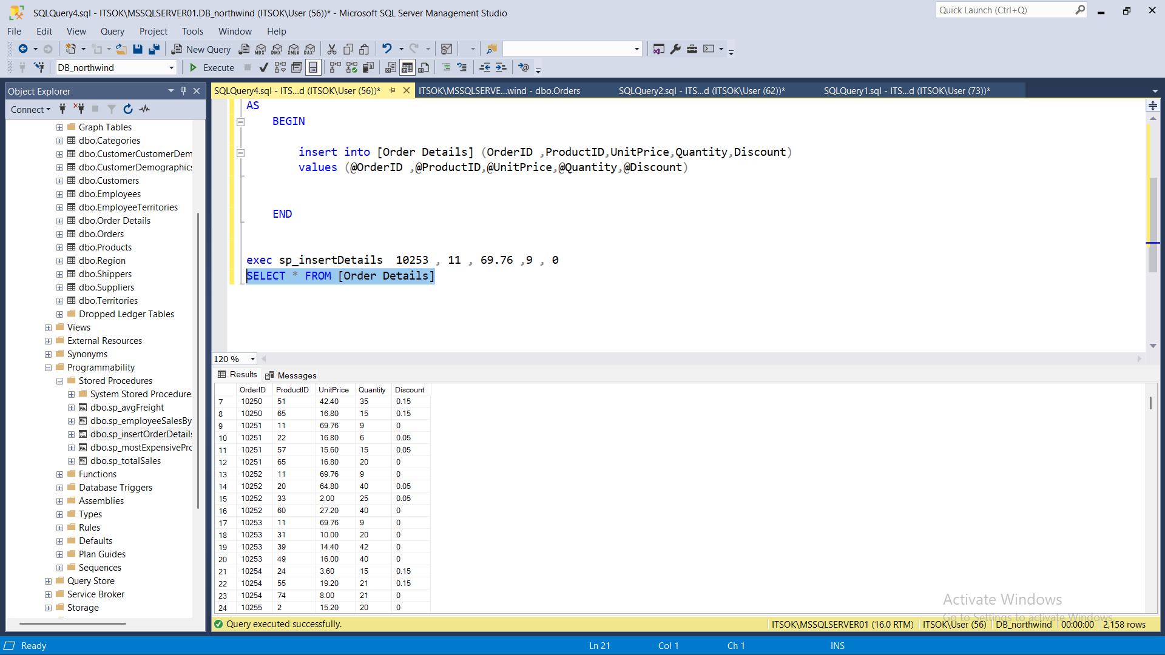

7. write a SQL query to Create Stored procedure in the Northwind database to update

Customer Order Details

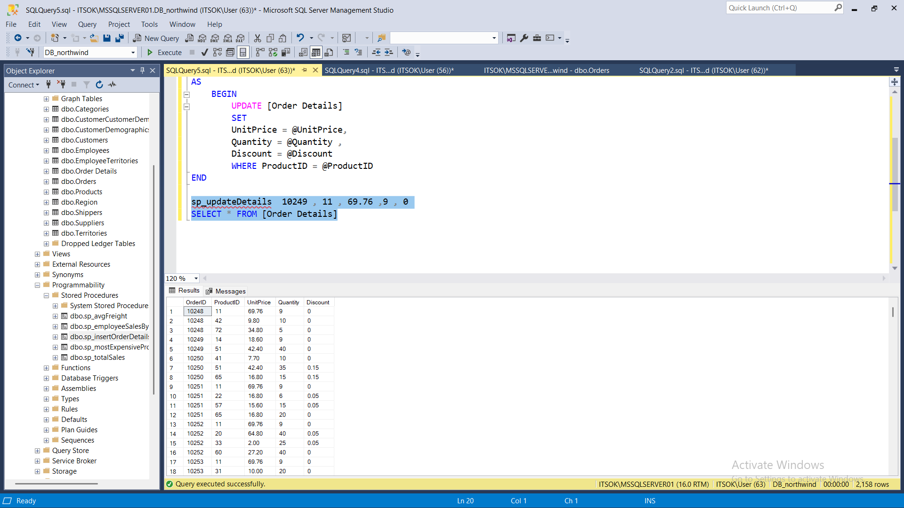

4. write a SQL query to Create Stored procedure in the Northwind database to retrieve

Sales By Category

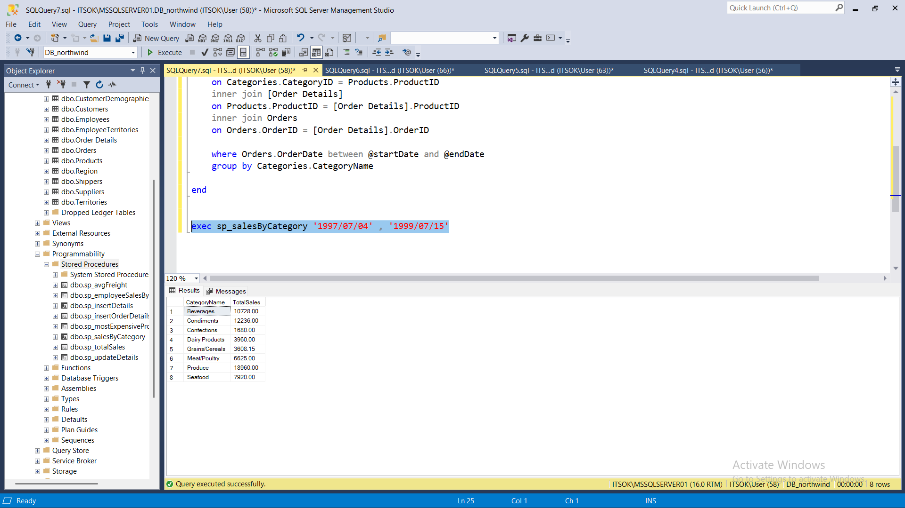

3. write a SQL query to Create Stored procedure in the Northwind database to retrieve

Sales by Year

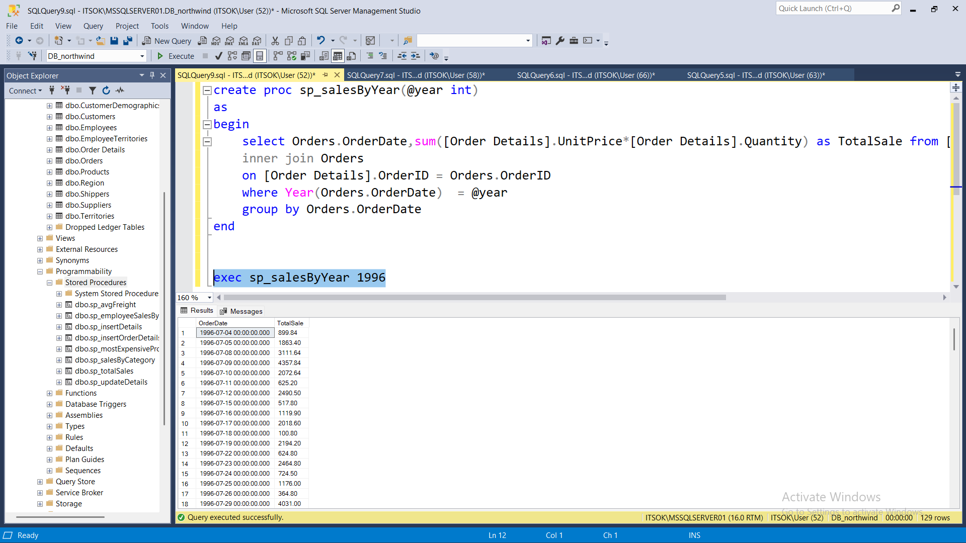

2. write a SQL query to Create Stored procedure in the Northwind database to retrieve

Employee Sales by Country

